Aim
To create storyboards representing the user flow for a mobile e-commerce application using Balsamiq.

Procedure
Step 1: Understand the Application Flow
- Identify the main features of the e-commerce app:
  - Product browsing
  - Product details
  - Add to cart
  - Checkout
  - Order confirmation
- Define the user journey:
  - User opens app → Searches product → Views product → Adds to cart → Makes payment → Receives confirmation

Step 2: Open Balsamiq Tool
- Launch Balsamiq.
- Create a new project/board.
- Set mobile screen size for designing.

Step 3: Create Storyboard Screens
Design each screen as a separate frame:
- Home Screen
  - Search bar
  - Featured products
  - Categories
- Product Listing Screen
  - List/grid of products
  - Filter and sort options
- Product Detail Screen
  - Product image
  - Price and description
  - “Add to Cart” button
- Cart Screen
  - Selected items
  - Quantity and total price
  - “Proceed to Checkout” button
- Checkout Screen
  - Shipping details
  - Payment method
- Order Confirmation Screen
  - Order summary
  - Confirmation message

Step 4: Add Navigation Flow
- Use arrows/connectors to show transitions between screens:
  - Home → Product List
  - Product List → Product Detail
  - Product Detail → Cart
  - Cart → Checkout
  - Checkout → Confirmation
- Label each transition clearly.

Step 5: Organize Storyboard
- Arrange screens in sequence (left to right or top to bottom).
- Add notes describing user actions (e.g., “User clicks Add to Cart”).

Step 6: Review and Refine
- Check if flow is logical and complete.
- Ensure usability:
  - Easy navigation
  - Clear buttons
  - Minimal confusion

Output
- Created a complete storyboard of a mobile e-commerce app including:
  - Home screen
  - Product listing
  - Product details
  - Cart
  - Checkout
  - Order confirmation
- Clearly defined navigation flow between screens.
- Visual representation of user interaction steps.
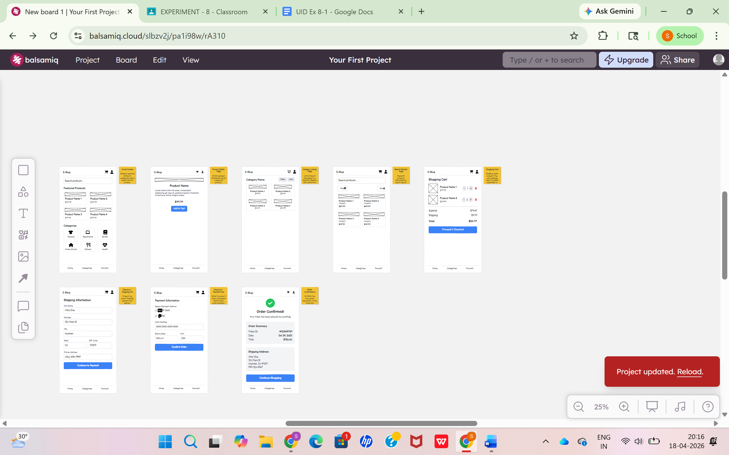

Result
The storyboard successfully represents the user flow of a mobile e-commerce application. It helps in:
- Understanding user interactions clearly
- Identifying usability issues early
- Improving app design before development.

